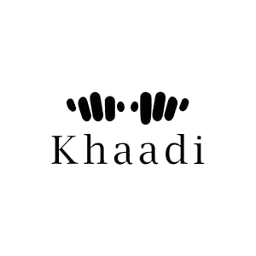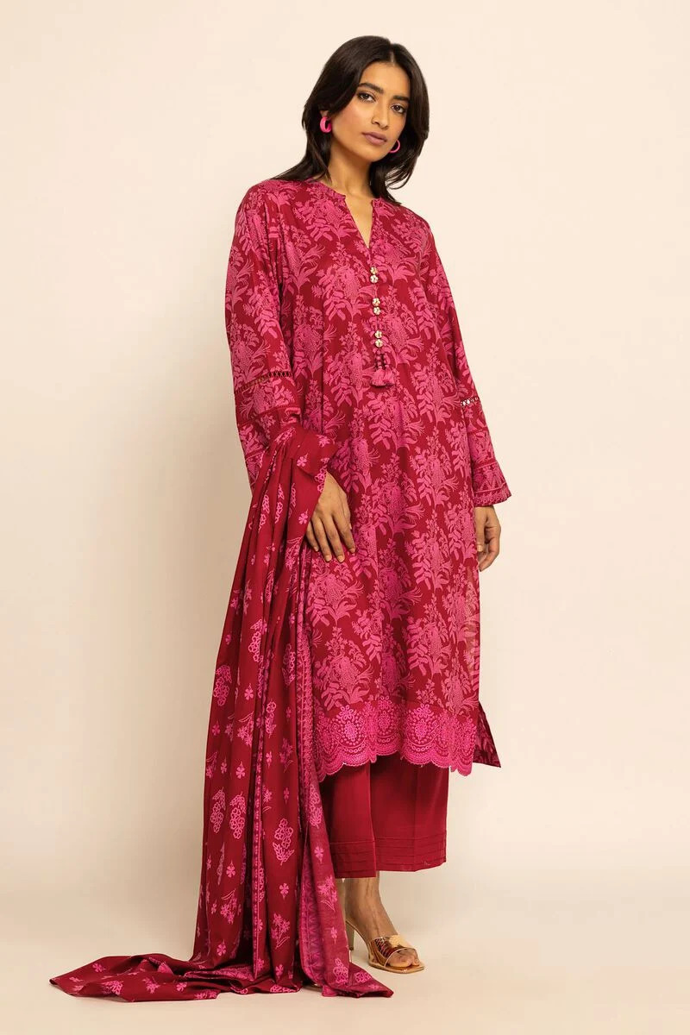

The three-piece dress you described, with its vibrant yellow color, thread shirt, and lawn fabric, represents the rich cultural heritage and traditional craftsmanship of Pakistan. It embodies the beauty and elegance of Pakistani fashion, combining traditional elements with contemporary trends. This ensemble is perfect for special occasions, festivals, or any event where you want to showcase the vibrant colors and intricate details of Pakistani traditional attire.

* **Details**
  + **Top Fabric:** Dyed Dobby | 3.25m
  + **Bottom Fabric:** Dyed Dobby | 2.5m
  + **Dupatta Fabric:** Digital Printed Cotton Square | 2.5m
  + **Campaign:** The Print Story